Docker challenges
- Create a customized Docker image using a Dockerfile.
Create index.html file
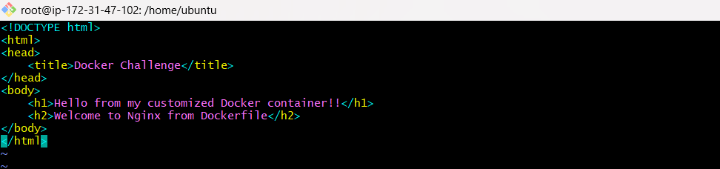
Create a docker file
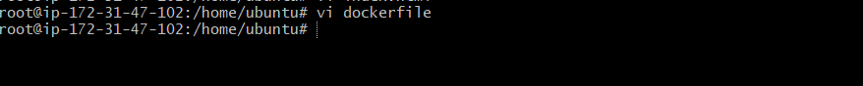
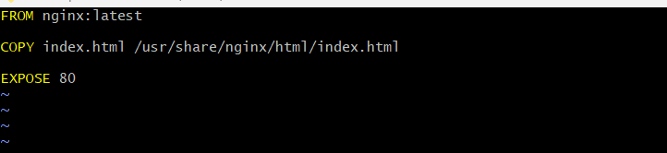
To build the image
Docker build -t nginx:v2
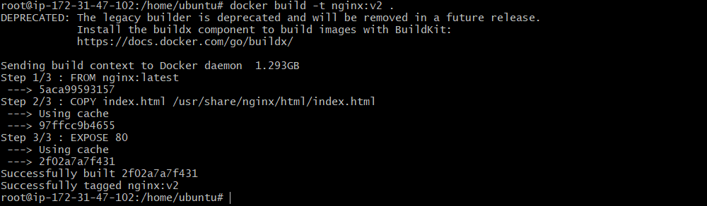
Run container
To check the image are download
Docker images
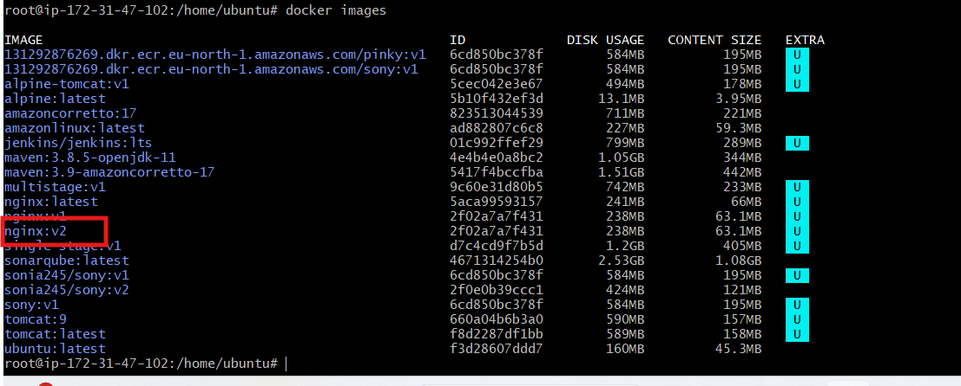
Verify the port number running or not
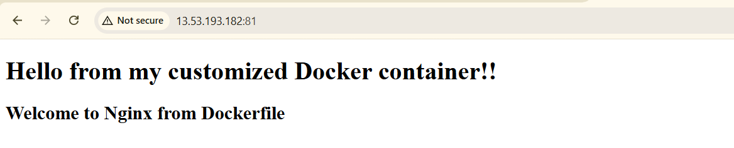

- Push the image to Docker Hub.
First create a one repo on docker hub
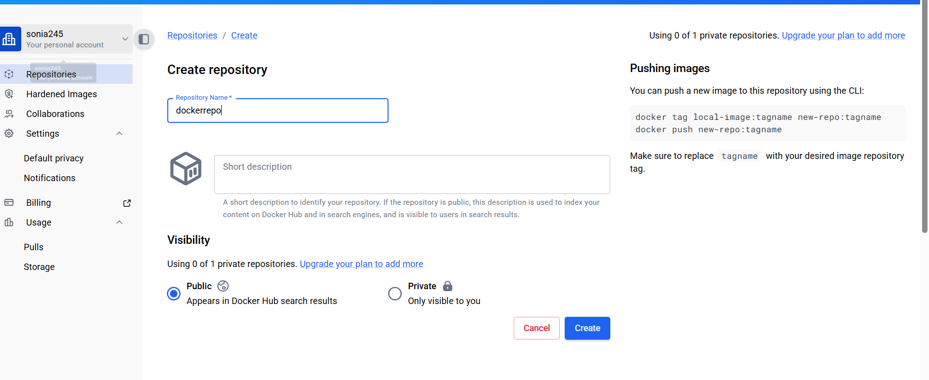
Login dockerhub
Docker login
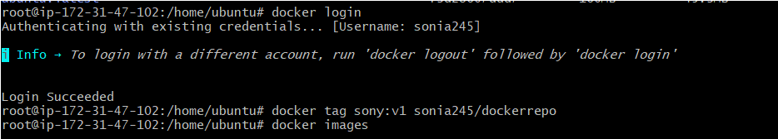
Tag the image
Docker tag sony:v1 sonia245/dockerrepo
To push the image
Docker push sonia245/dockerrepo:latest
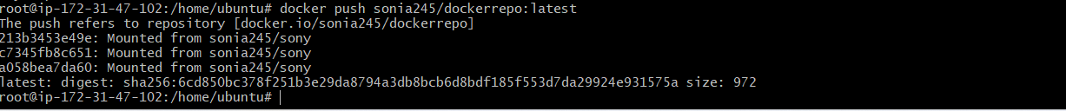
To verify the docker hub
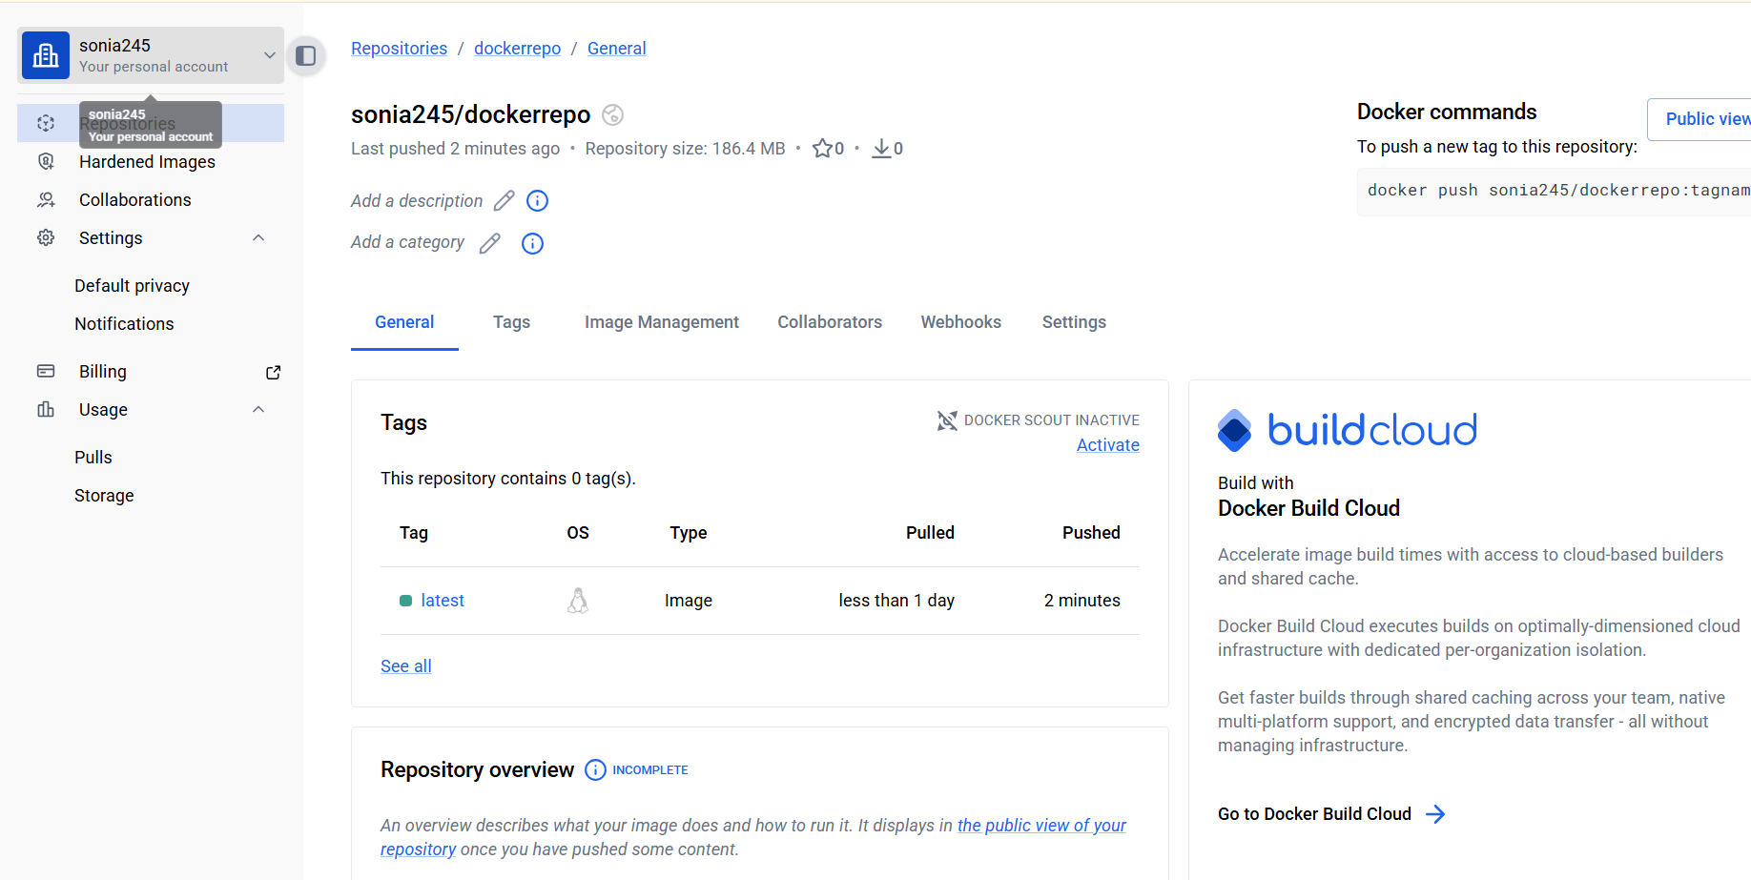

- Push the same image to Amazon ECR.
Open aws cer and create a repo
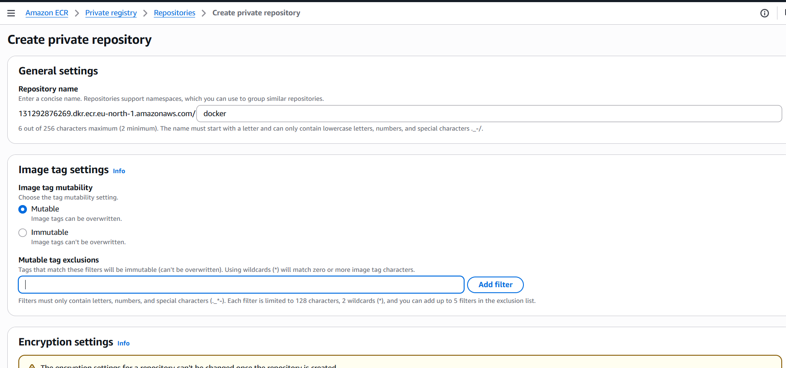
Created new repo
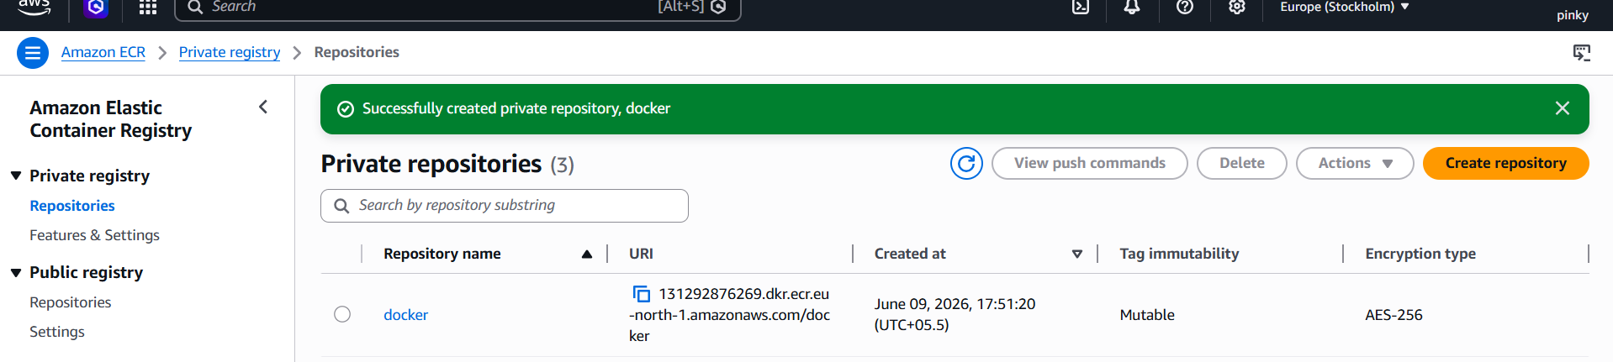
Login with AWS configure cli
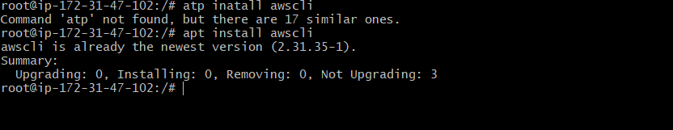
aws sts get-caller-identity
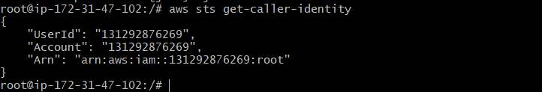
Login to aws ECR
aws ecr get-login-password --region eu-north-1 | \
docker login --username AWS --password-stdin 131292876269.dkr.ecr.eu-north-1.amazonaws.com
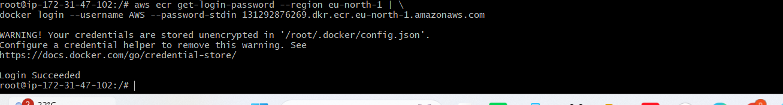
Rename the image
Docker tag multistage:v1 131292876269.dkr.ecr.eu-north-1.amazonaws.com/docker:v3
Docker push 131292876269.dkr.ecr.eu-north-1.amazonaws.com/docker:v3
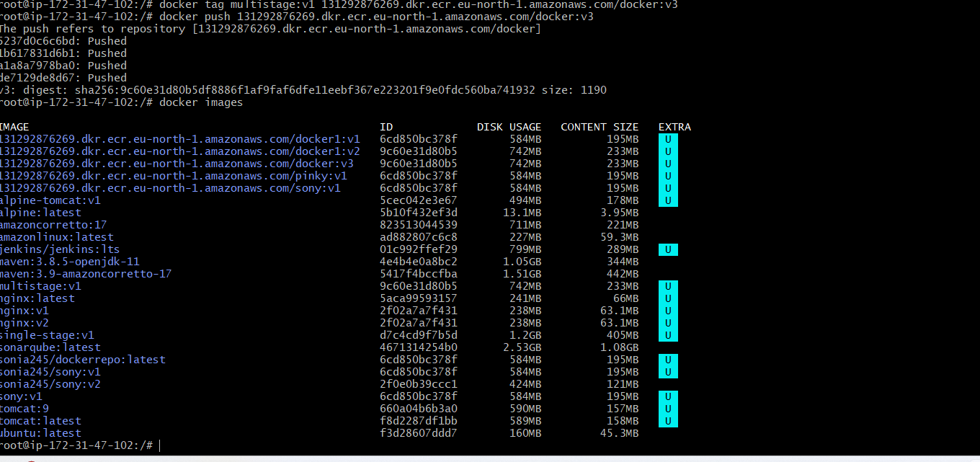
Lets check in the AWS ECR
It has been pushed successfully
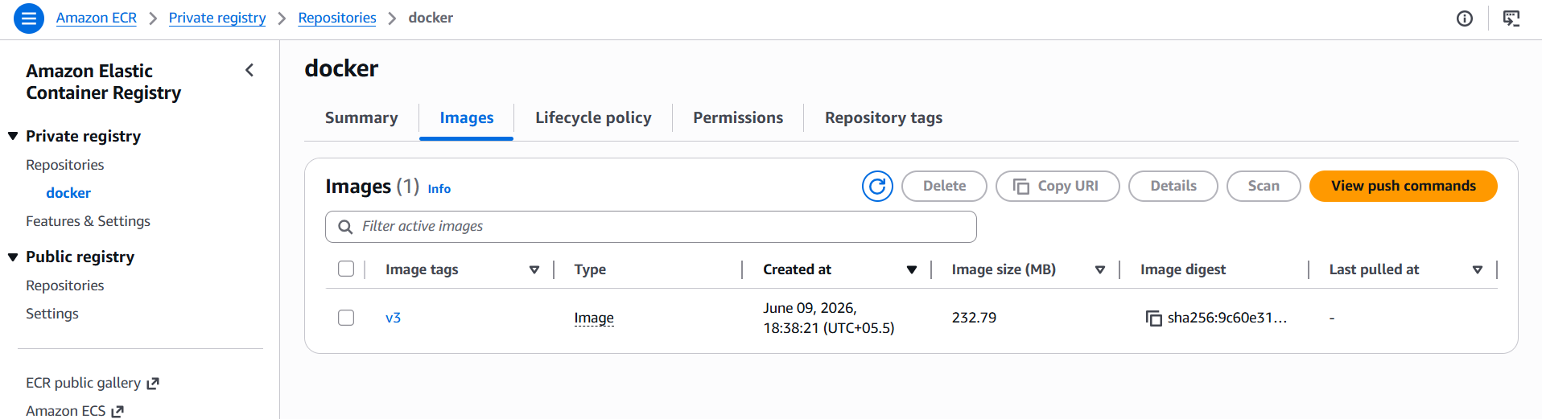

- Provision one EC2 instance using Terraform and install Jenkins.
Lets install this commands all
wget -O - https://apt.releases.hashicorp.com/gpg | sudo gpg --dearmor -o /usr/share/keyrings/hashicorp-archive-keyring.gpg
echo "deb [arch=$(dpkg --print-architecture) signed-by=/usr/share/keyrings/hashicorp-archive-keyring.gpg] https://apt.releases.hashicorp.com $(grep -oP '(?<=UBUNTU_CODENAME=).*' /etc/os-release || lsb_release -cs) main" | sudo tee /etc/apt/sources.list.d/hashicorp.list
sudo apt update && sudo apt install terraform
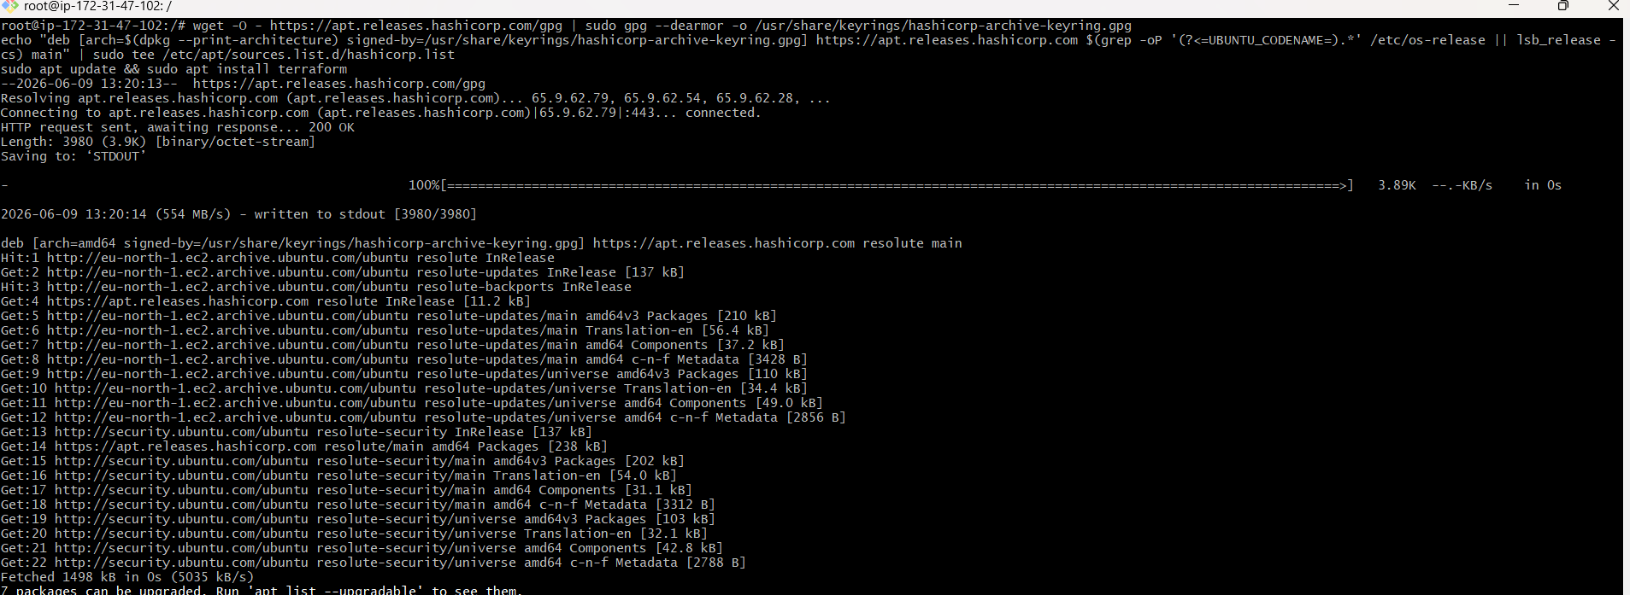
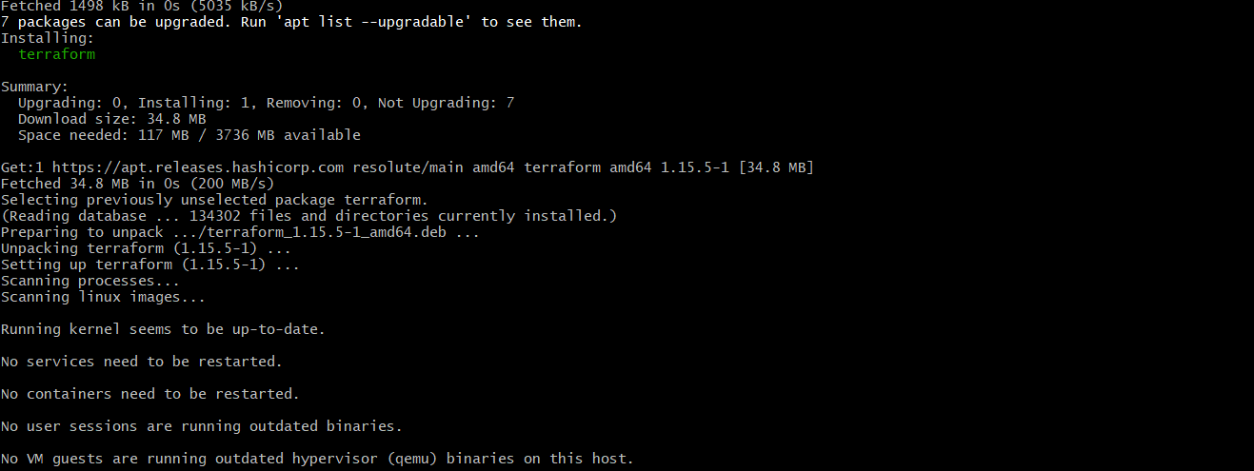
Lets confirm if terraform has been installed or not
terraform –version
Aws configure
Aws sts get-caller-identity
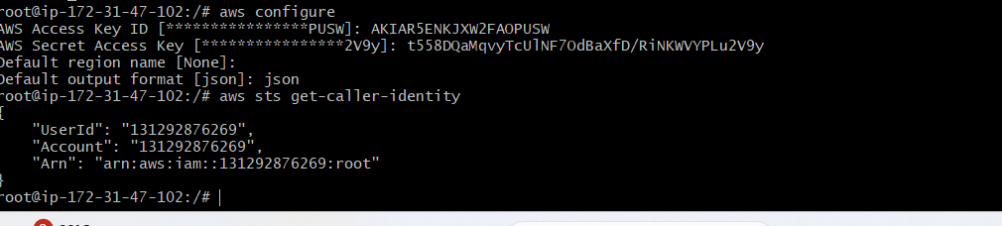
Create a directory and changing to that directory i will be using the command
mkdir terraform-jenkins / cd terraform-jenkins
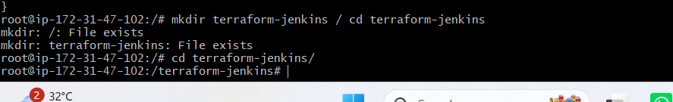
Inside Terraform-jenkins folder lets create some files using
touch main.tf variables.tf terraform.tfvars userdata.sh
Lets add userdata for installing jenkins through terraform in userdata
Why are we using user-data?
AWS runs this script automatically during EC2 launch, so Jenkins gets installed without manual steps.

#!/bin/bash
# Update packages
apt update -y
# Install Java 21
apt install openjdk-21-jdk -y
# Create keyrings directory
mkdir -p /etc/apt/keyrings
# Add Jenkins key
wget -O /etc/apt/keyrings/jenkins-keyring.asc \
https://pkg.jenkins.io/debian-stable/jenkins.io-2026.key
# Add Jenkins repository
echo "deb [signed-by=/etc/apt/keyrings/jenkins-keyring.asc] \
https://pkg.jenkins.io/debian-stable binary/" | sudo tee \
/etc/apt/sources.list.d/jenkins.list > /dev/null
# Update packages again
apt update -y
# Install Jenkins
apt install jenkins -y
# Enable and start Jenkins
systemctl enable jenkins
systemctl start jenkins
leats create vi userdata.sh
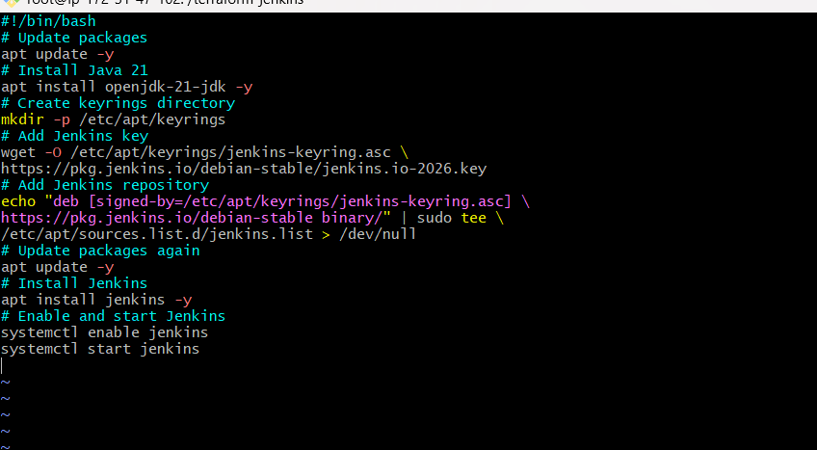
Lets add variables in Create vi variables.tf
variable "aws_region" {
default = "us-east-1"
}

variable "instance_type" {
default = "t3.small"
}

variable "key_name" {
description = "AWS Key Pair Name"
}
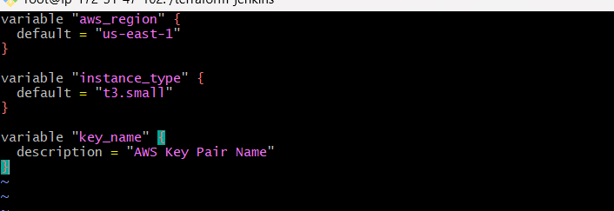
Lets open vi terraform.tfvars

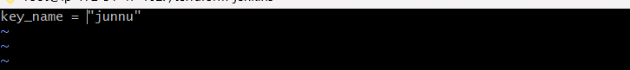
Lets create vi main.tf file
provider "aws" {
region = var.aws_region
}

# Get latest Ubuntu AMI
data "aws_ami" "ubuntu" {
most_recent = true

owners = ["099720109477"]

filter {
name = "name"
values = ["ubuntu/images/hvm-ssd-gp3/ubuntu-noble-24.04-amd64-server-*"]
}
}

# Security Group
resource "aws_security_group" "jenkins_sg" {
name = "jenkins-security-group"

ingress {
description = "SSH"
from_port = 22
to_port = 22
protocol = "tcp"
cidr_blocks = ["0.0.0.0/0"]
}

ingress {
description = "Jenkins"
from_port = 8080
to_port = 8080
protocol = "tcp"
cidr_blocks = ["0.0.0.0/0"]
}

ingress {
description = "HTTP"
from_port = 80
to_port = 80
protocol = "tcp"
cidr_blocks = ["0.0.0.0/0"]
}

egress {
from_port = 0
to_port = 0
protocol = "-1"
cidr_blocks = ["0.0.0.0/0"]
}
}

# EC2 Instance
resource "aws_instance" "jenkins_server" {
ami = data.aws_ami.ubuntu.id
instance_type = var.instance_type
key_name = var.key_name
vpc_security_group_ids = [aws_security_group.jenkins_sg.id]

user_data = file("userdata.sh")

tags = {
Name = "Jenkins-Server"
}
}

# Output Public IP
output "public_ip" {
value = aws_instance.jenkins_server.public_ip
}

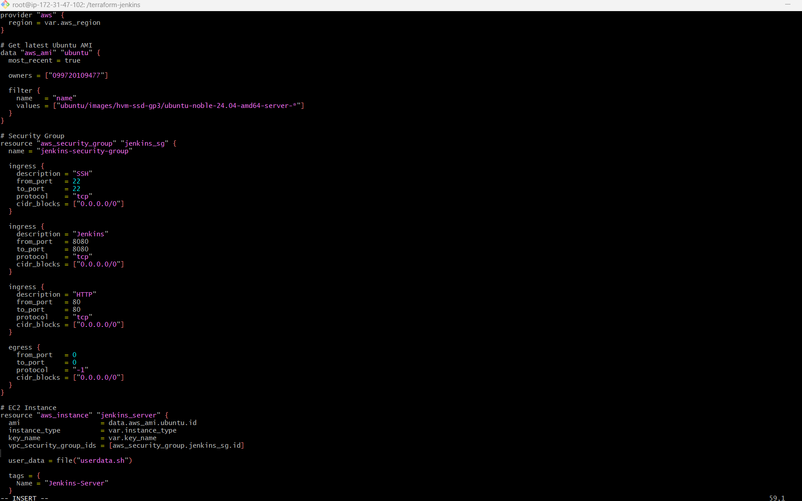
Lets Intilialize terraform using command
What does it does? Downloads AWS provider and Initializes Terraform project
Terraform init

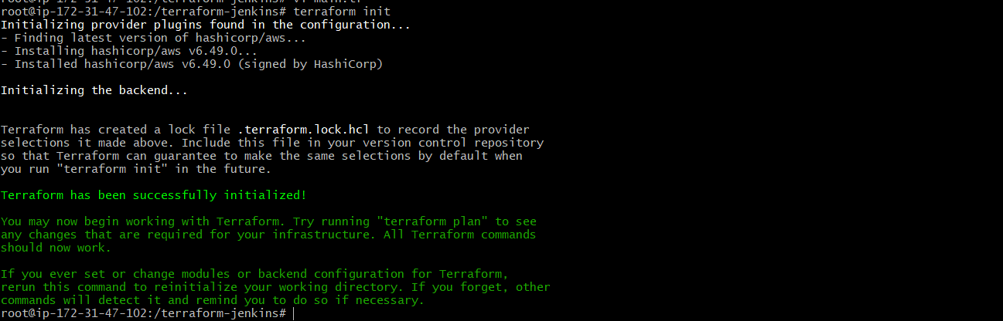
Validating the code using
terraform validate
Lets preview the infrastructure using
This shows: EC2 creation and Security group creation
Terraform plan
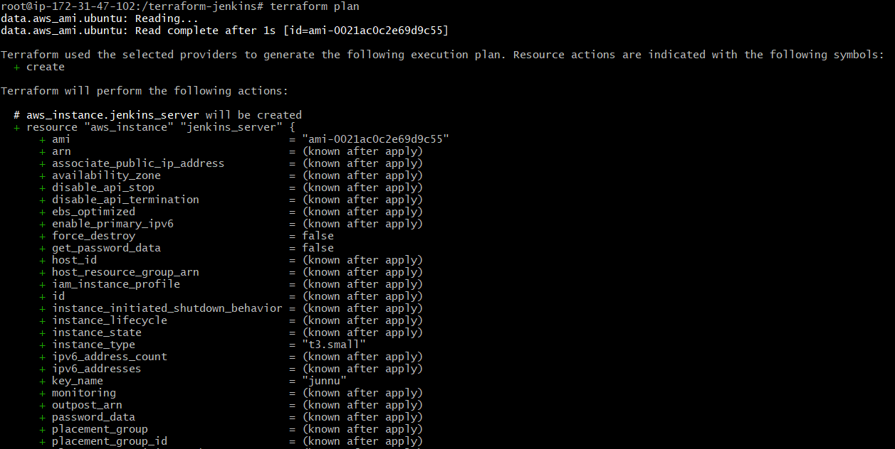
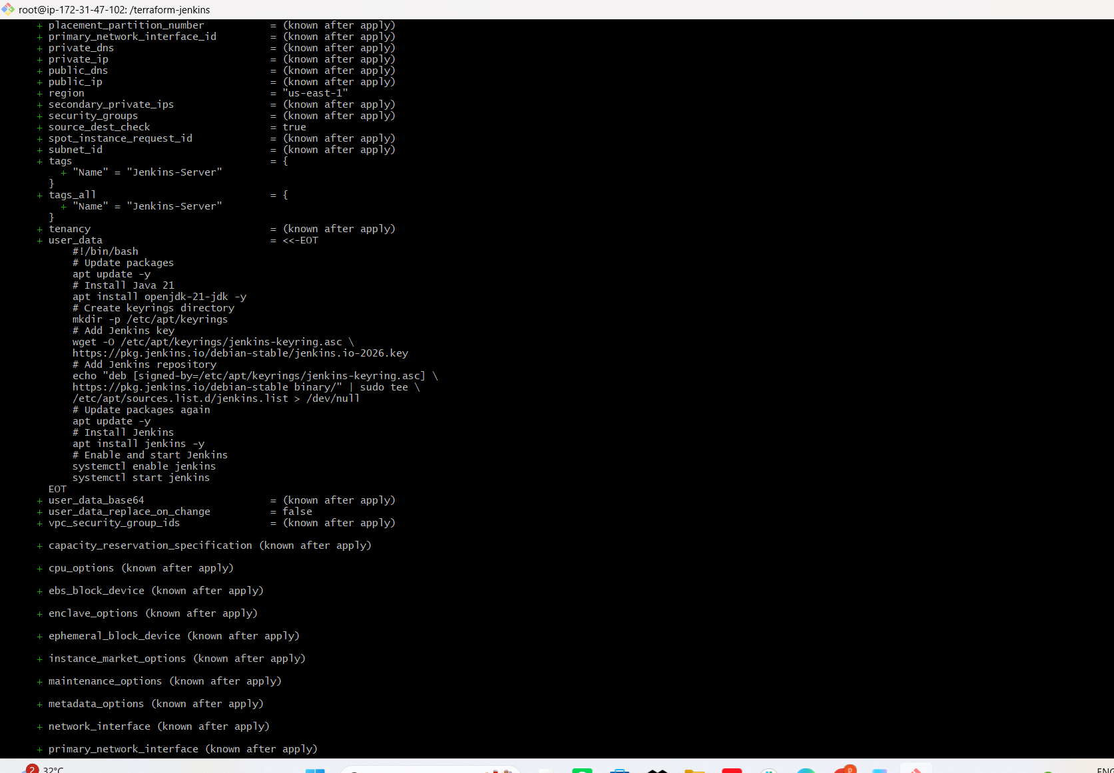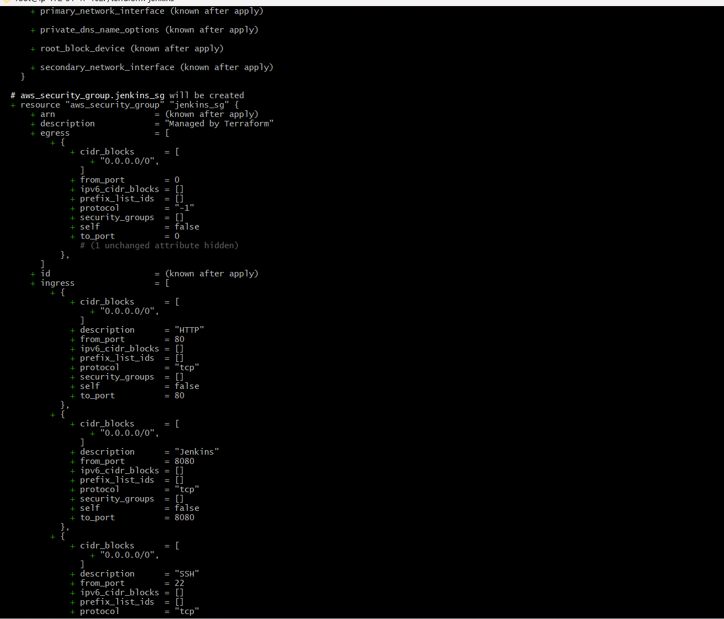
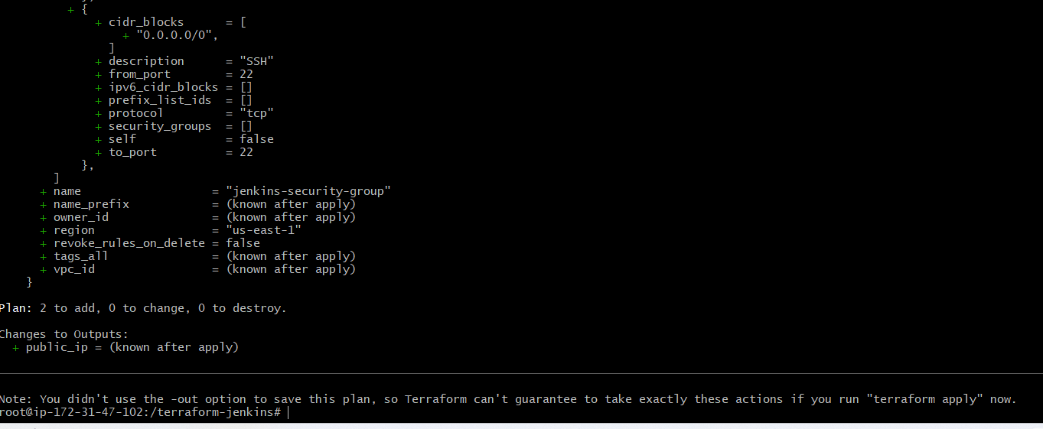
LEts create the Infrastructure now using
terraform apply
It will start create aws instance
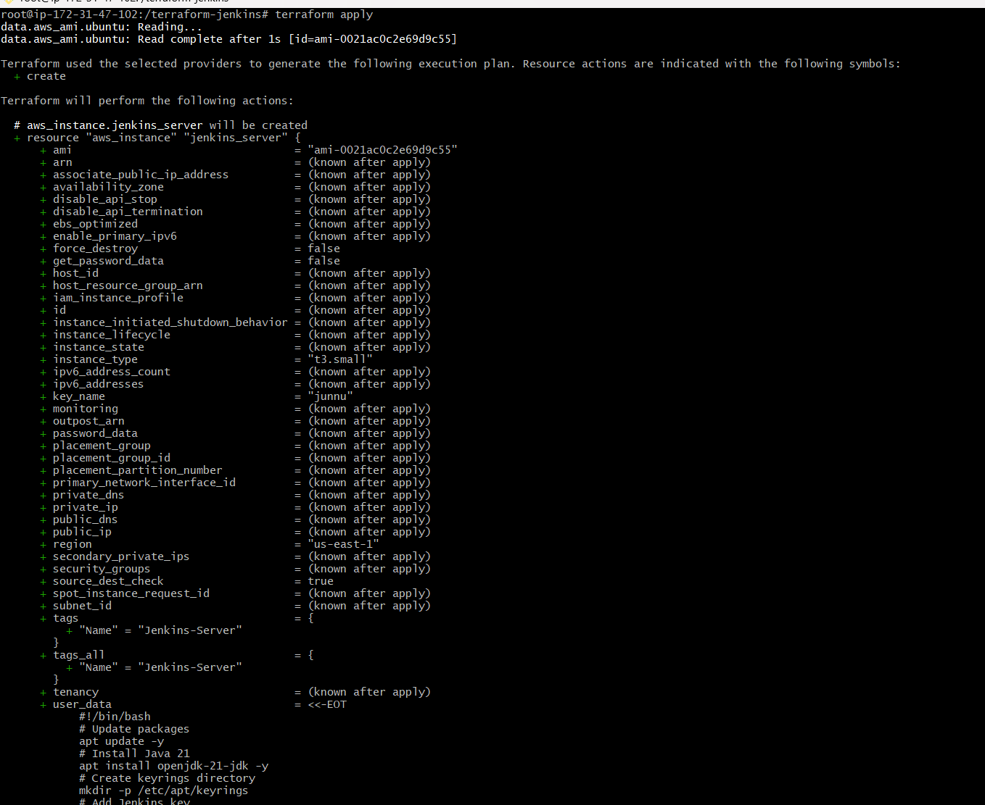
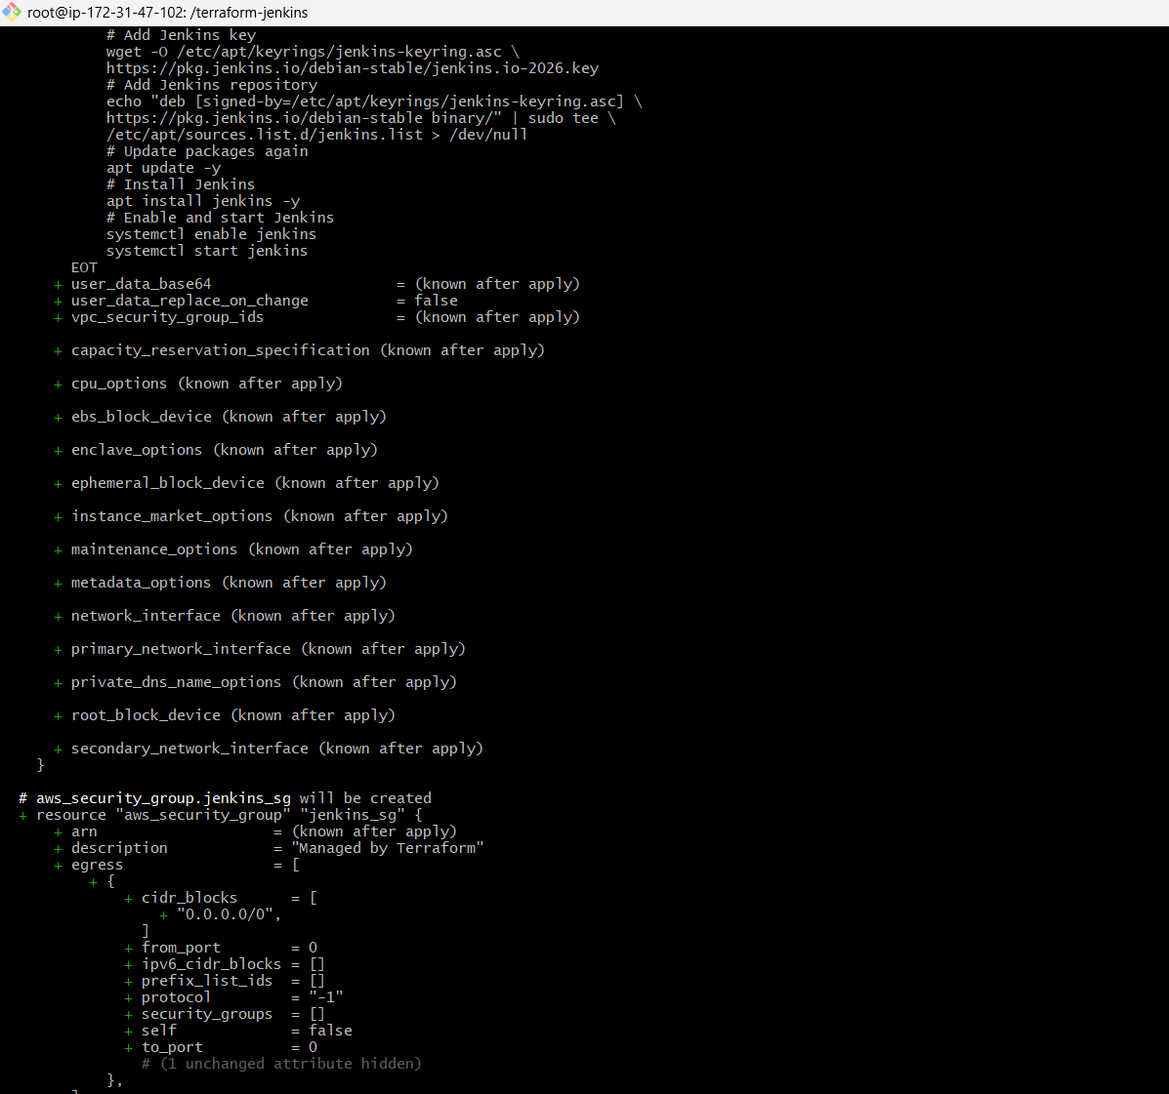
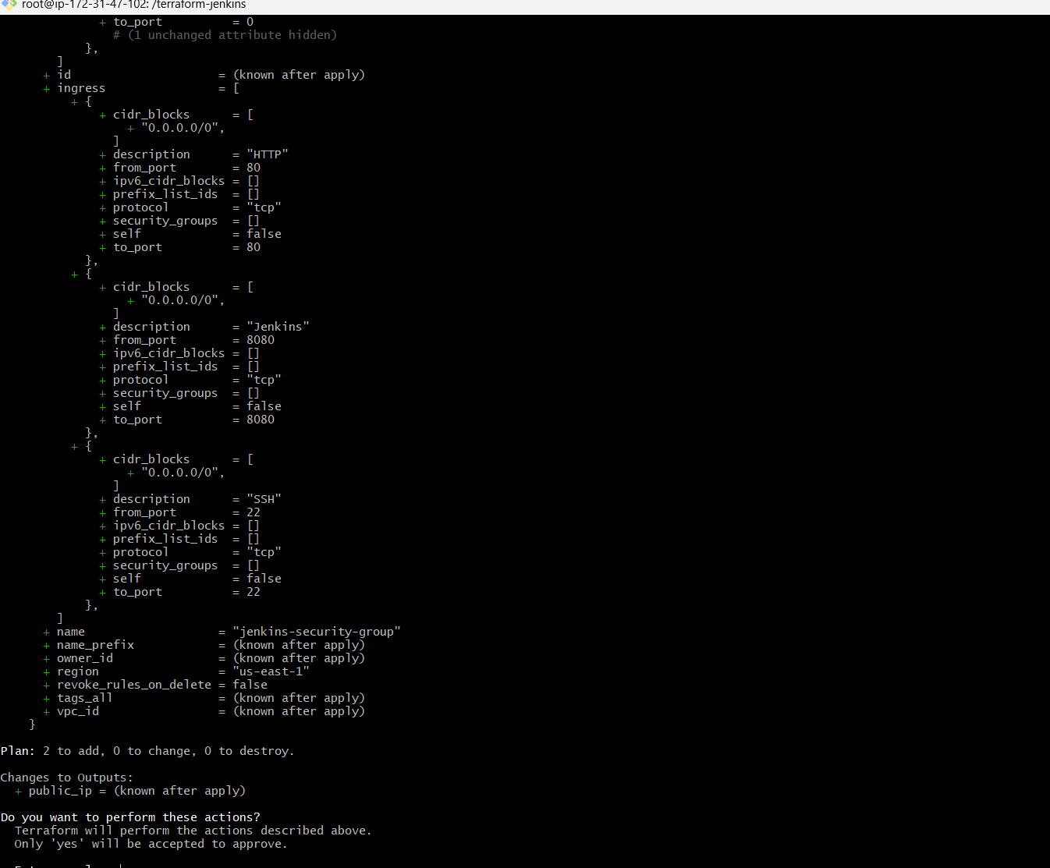

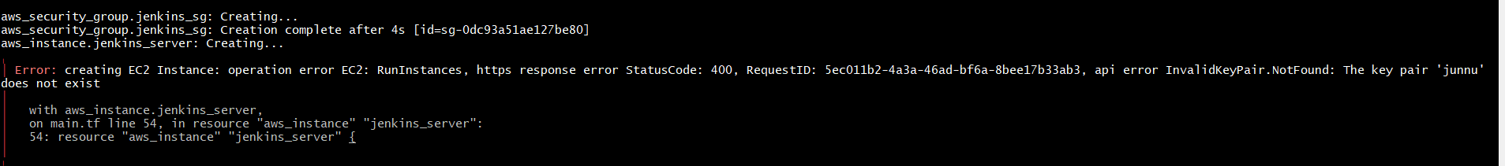
I got error an terraform apply so
I can go change to give public ip address and default subnet
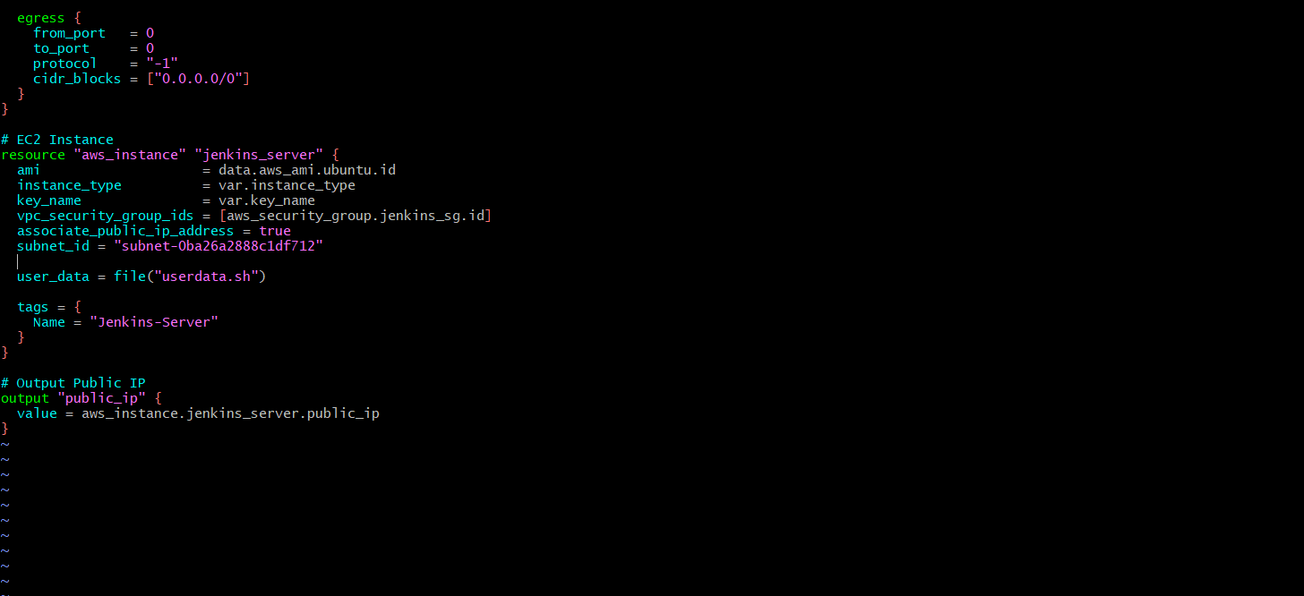
Again I got error because already created the security groups
So we can destroy the terraform
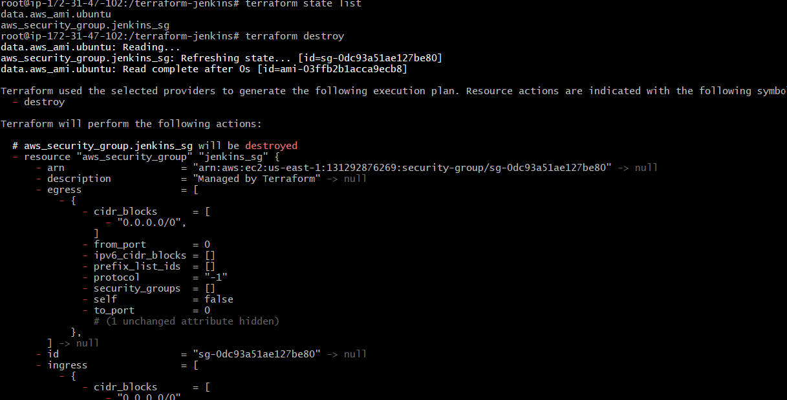
And again terraform apply
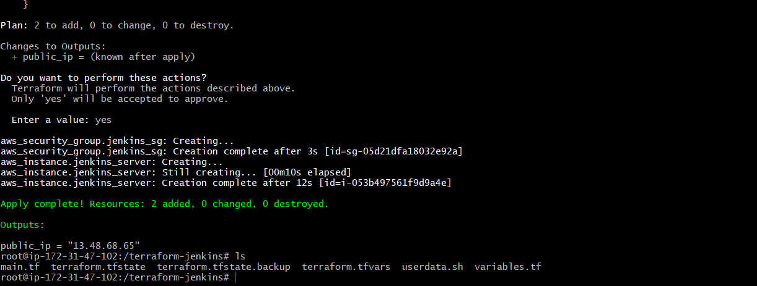
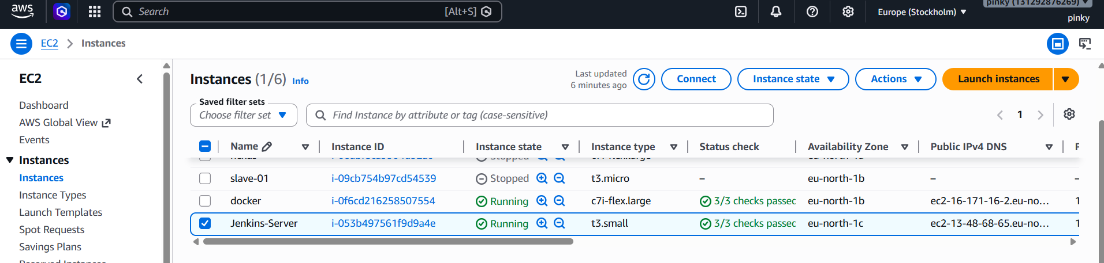
Connect to ec2 instancesysytemctl status jenkins
Jenkins are run successfully
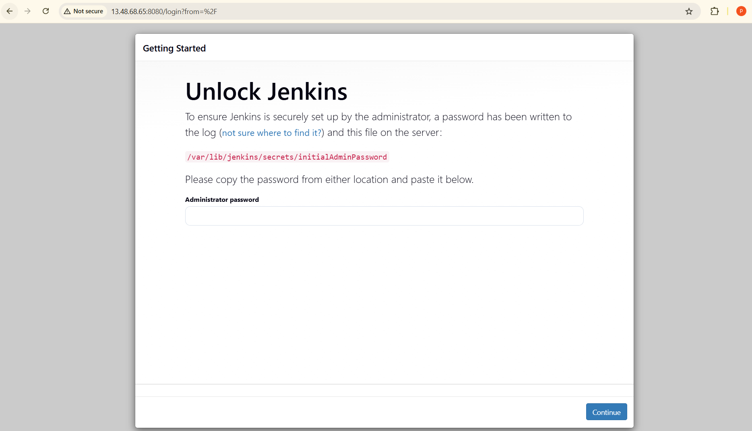

- Create one Jenkins job to build and push the Docker image to Docker Hub.
  - Source:https://github.com/betawins/Python-app.git
docker run -d --name jenkins-server --restart unless-stopped -p 9090:8080 -p 50000:50000 -v jenkins_home:/var/jenkins_home -v /var/run/docker.sock:/var/run/docker.sock -u root jenkins/jenkins:lts

Lets fork the repo and change the Dockerfile, because its using the old versions of python
FROM python:3.11-slim

WORKDIR /opt

COPY . .

RUN pip install --no-cache-dir flask

EXPOSE 8080

CMD ["python", "app.py"]
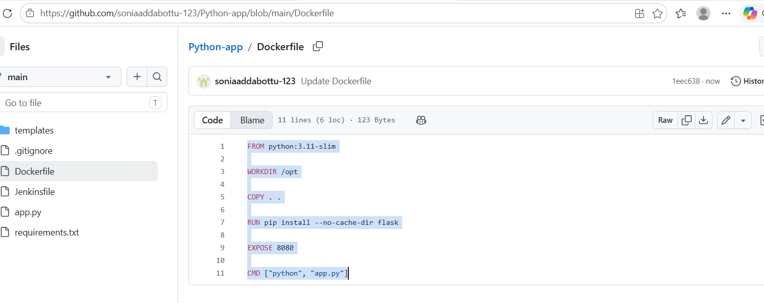
Lets create new item
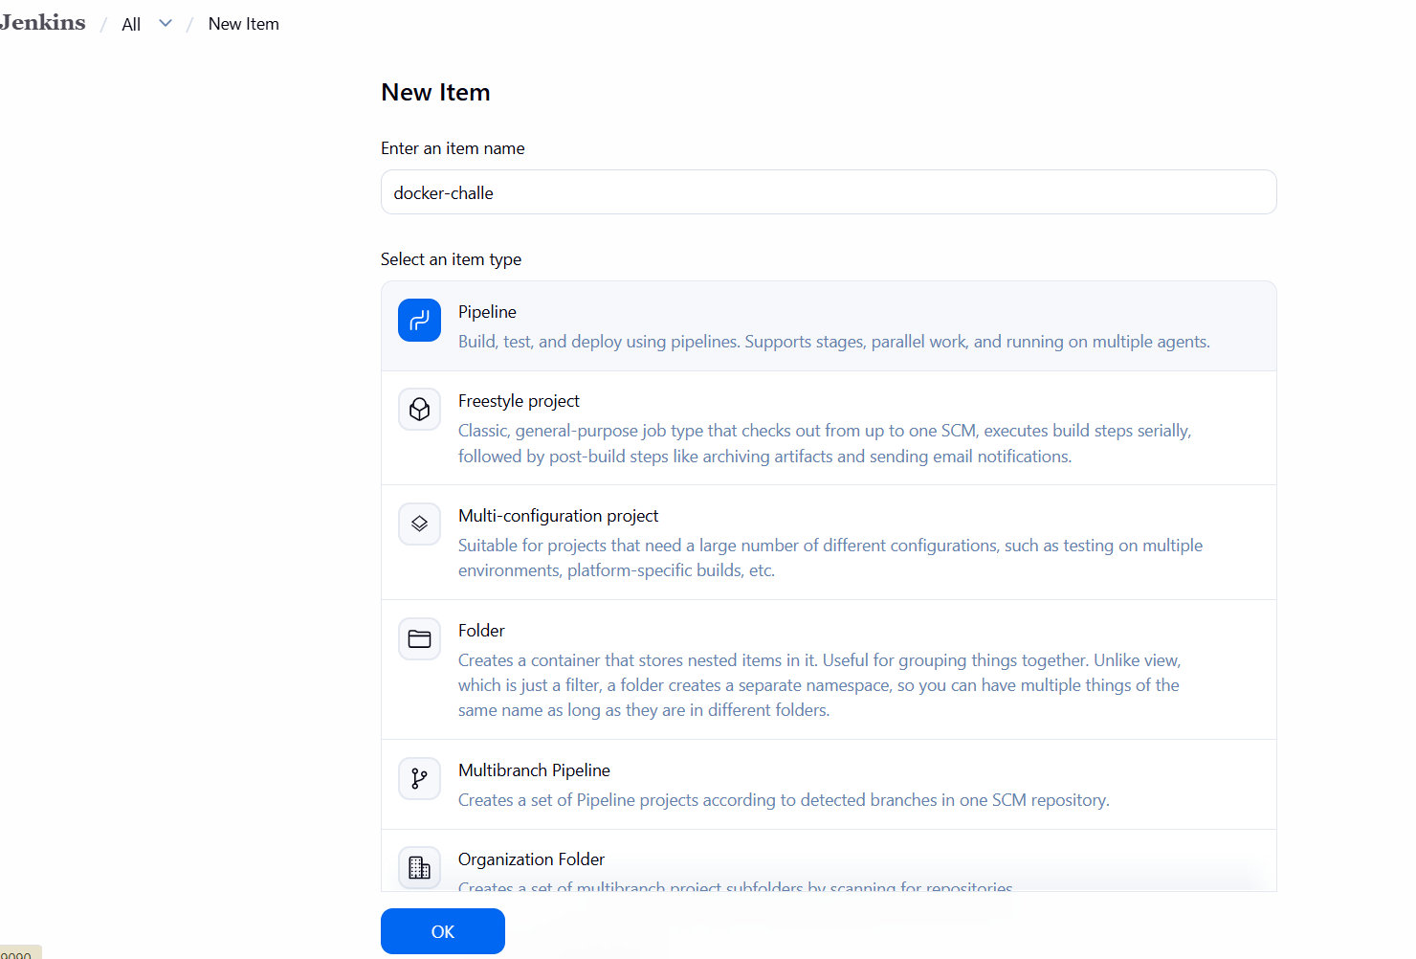
pipeline {
agent any

environment {
IMAGE_NAME = "sonia245/dockrrepo"
IMAGE_TAG = "v2"
}

stages {

stage('Clone Code') {
steps {
git(
branch: 'main',
url: 'https://github.com/soniaaddabottu-123/Python-app.git'
)
}
}

stage('Build Docker Image') {
steps {
sh 'docker build -t $IMAGE_NAME:$IMAGE_TAG .'
}
}

stage('Login DockerHub') {
steps {
withCredentials([
usernamePassword(
credentialsId: 'dockerhub-cred',
usernameVariable: 'DOCKER_USER',
passwordVariable: 'DOCKER_PASS'
)
]) {
sh '''
echo $DOCKER_PASS | docker login \
-u $DOCKER_USER \
--password-stdin
'''
}
}
}

stage('Push Image') {
steps {
sh 'docker push $IMAGE_NAME:$IMAGE_TAG'
}
}
}

post {
success {
echo 'Docker image pushed successfully!'
}

failure {
echo 'Pipeline failed!'
}
}
}
Above script written on blow
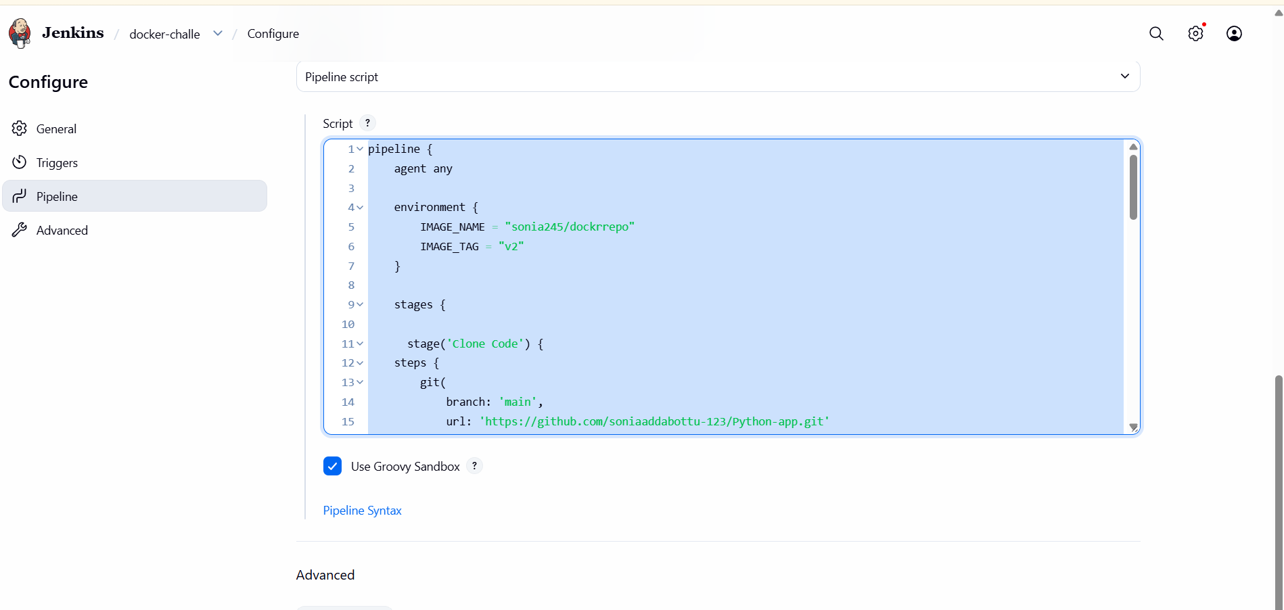
After that the build is failed
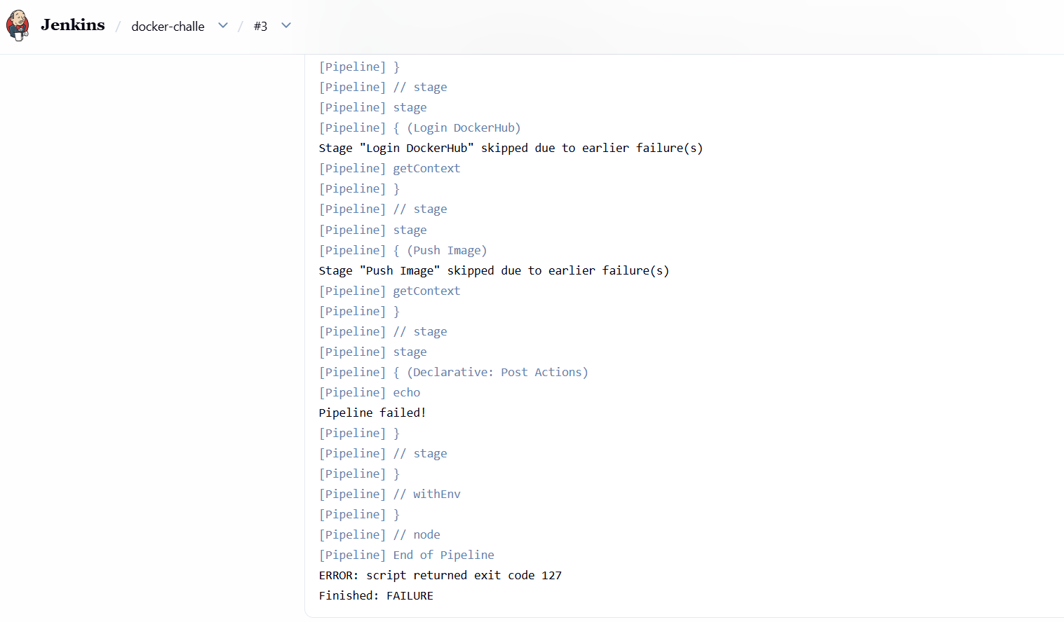
Because docker contaoner is inside

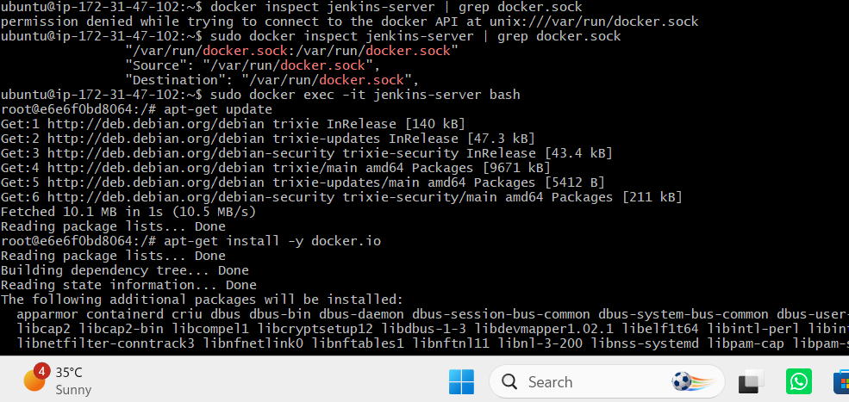
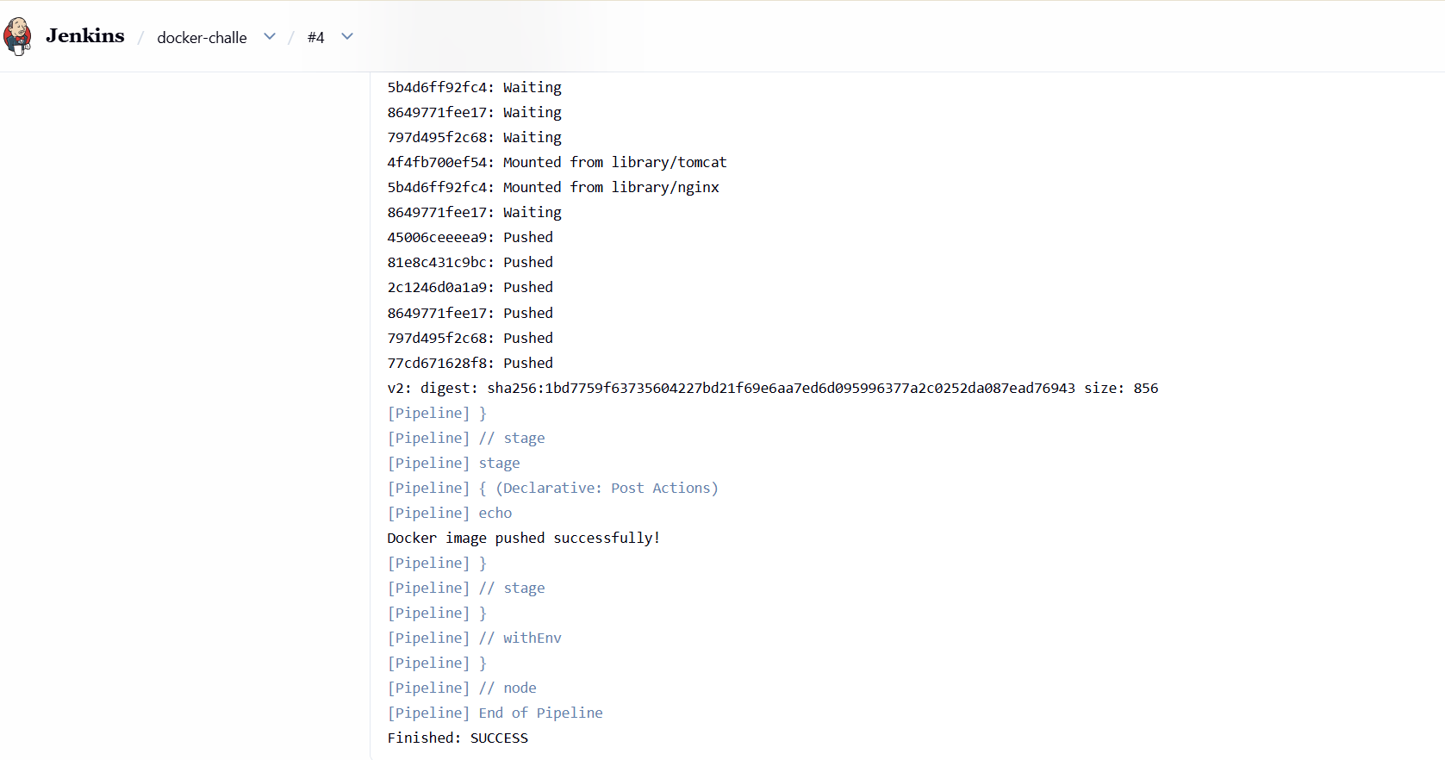
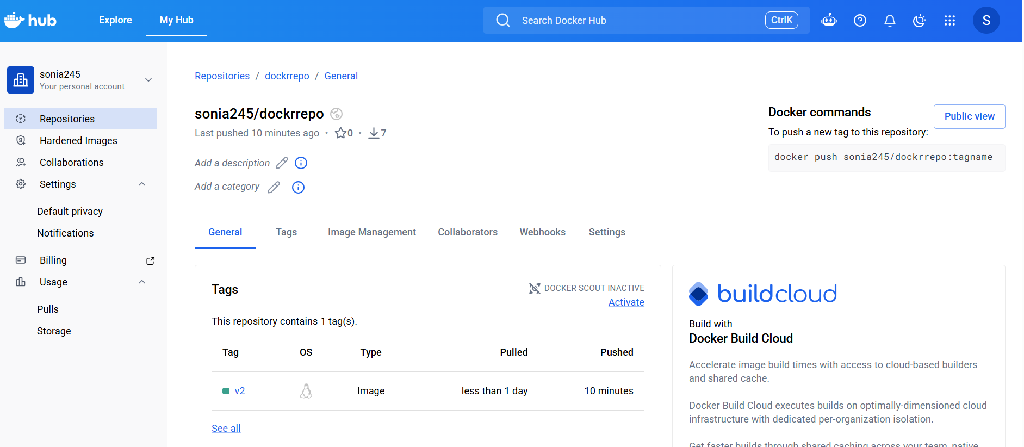

6) Source Codes: https://github.com/betawins/docker-tasks.git
- From thefrontend source code, write a Dockerfile, build a Docker image, run it, and push that image to your Docker registry.
First we clone the source code
Git clone https://github.com/betawins/docker-tasks.git

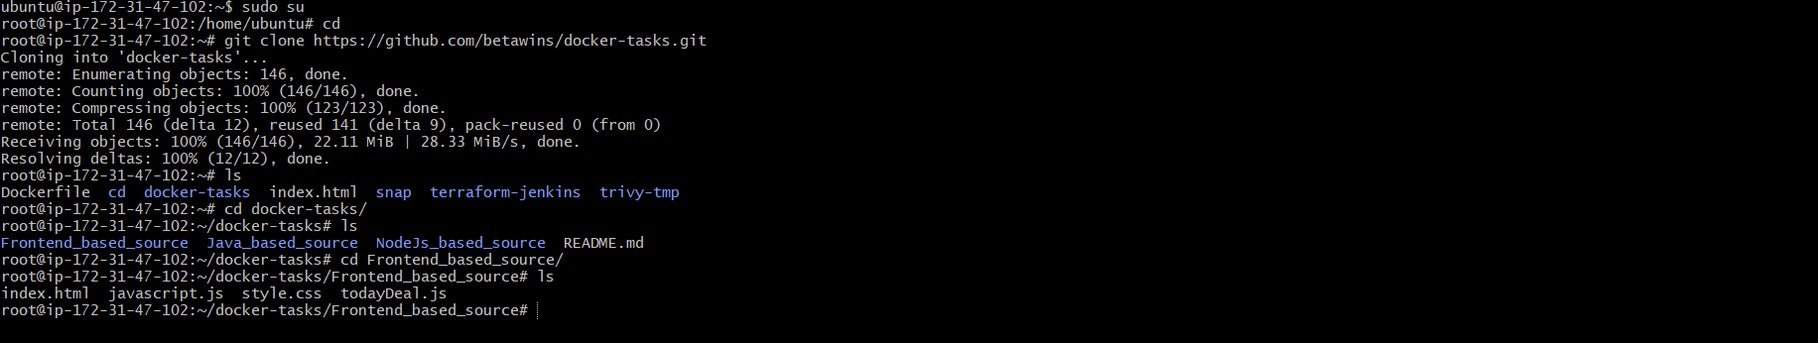
Lets create dockerfile
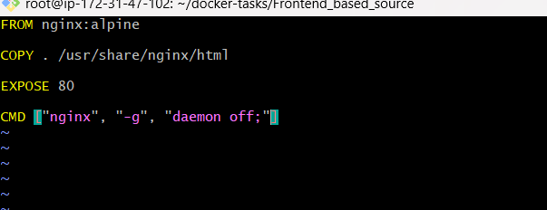
This docker file downloads the latest nginx image and copies all the files from current
directory to /usr/share/nginx/html
Lets now build the image using command
docker build -t frontend-app:v1 .
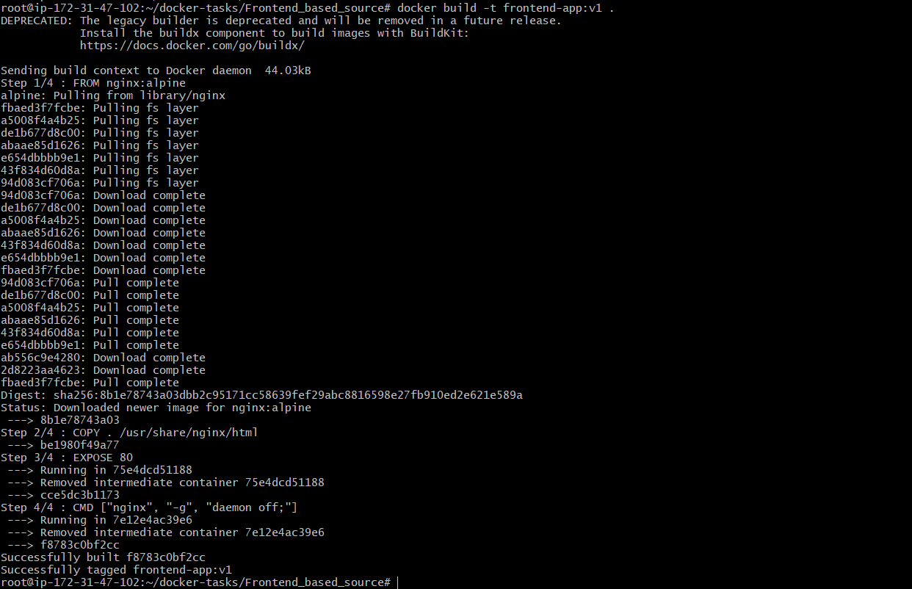
We can check image is download
Docker images
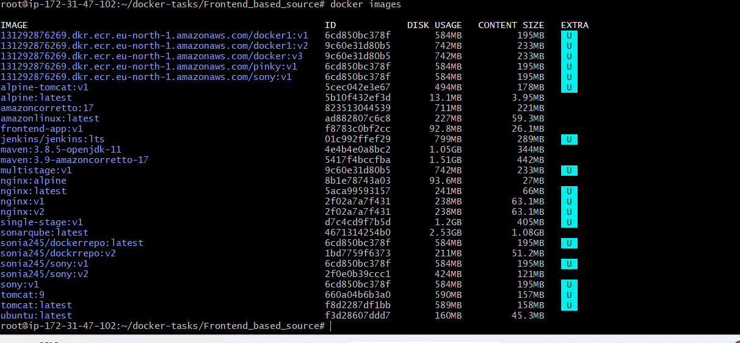docker run -d --name frontend-container -p 8087:80 frontend-app:v1
And Docker ps
Lets check if its Access in Browser
Lets push it to docker hub
First cretate repo in dockerhub
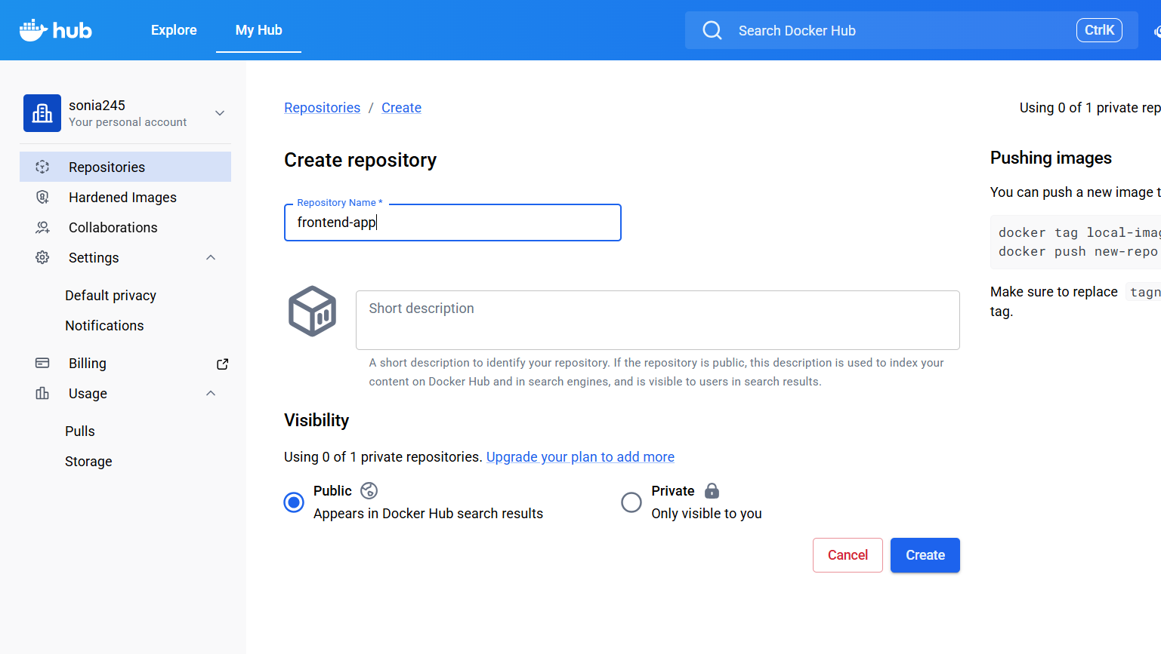docker tag frontend-app:v1 bharu31/frontend-app:v1
docker login
docker push javeebms7/frontend-app:v1
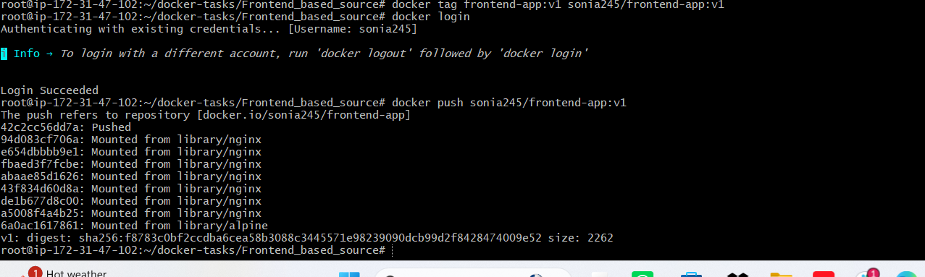
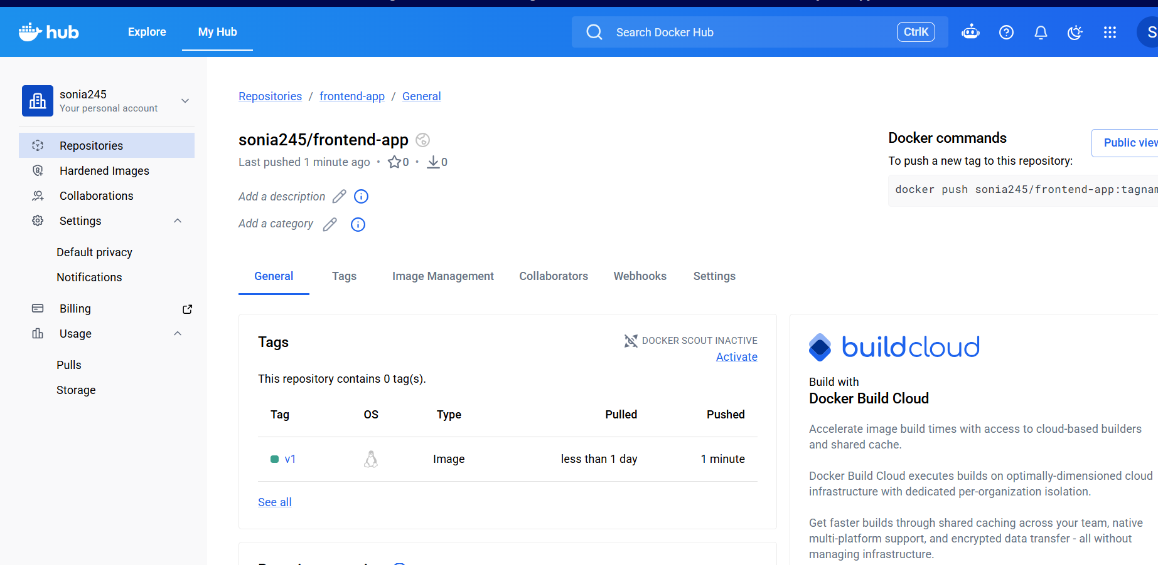

- From theJava-based source code, write a Dockerfile, build, run, and push the image to the Docker registry.
Now let’s do the Java-based source code properly.
First go into the Java project:
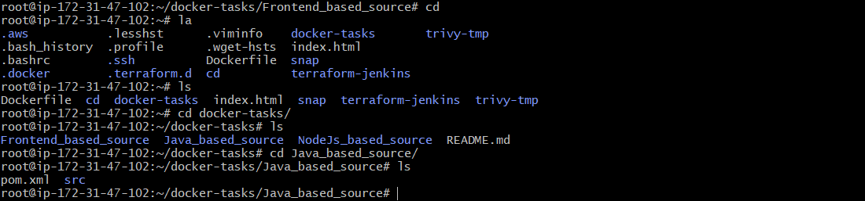
# Use Maven to build application
FROM maven:3.9.6-eclipse-temurin-17 AS build

WORKDIR /app

COPY . .

RUN mvn clean package -DskipTests

# Runtime image
FROM eclipse-temurin:17-jdk-alpine

WORKDIR /app

COPY --from=build /app/target/*.jar app.jar

EXPOSE 8080

CMD ["java", "-jar", "app.jar"]
Lets create dockerfile
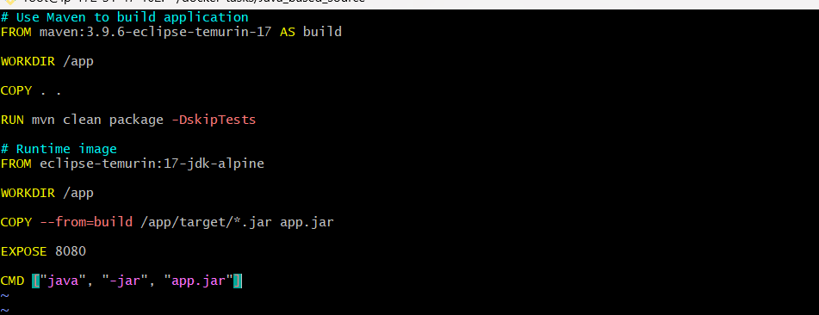
This Dockerfile is a multi-stage Dockerfile used to build and run the Java application efficiently. In the first stage, it uses a Docker image with Maven and Java to build the project and generate the JAR file. It creates a working directory called /app and copies all project files into the container. After building the application, the second stage uses a smaller Java runtime image to reduce image size. It copies only the generated JAR file from the build stage and exposes port 8080 to access the application. Finally, it starts the application using the command java -jar app.jar. This approach makes the Docker image smaller, cleaner, and efficient.
Lets build the image using command
docker build -t java-app:v1 .
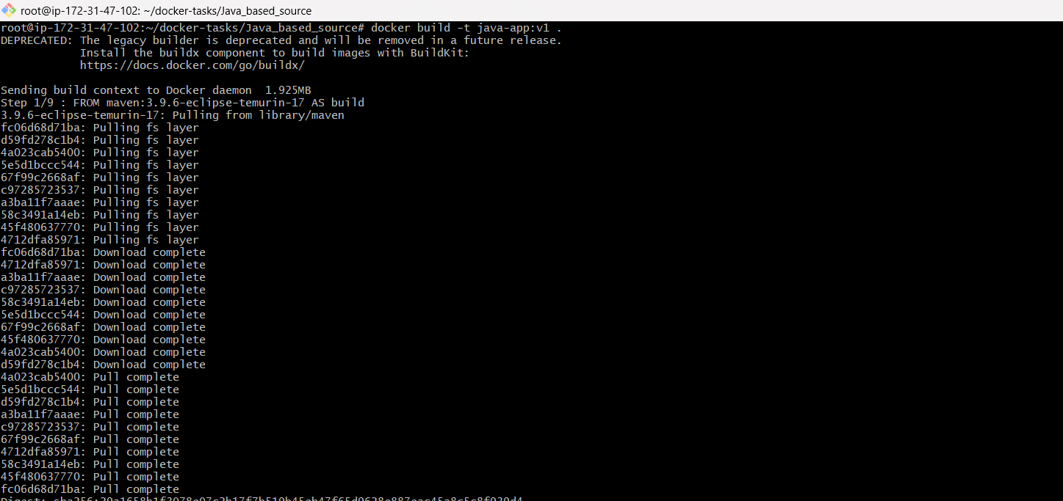
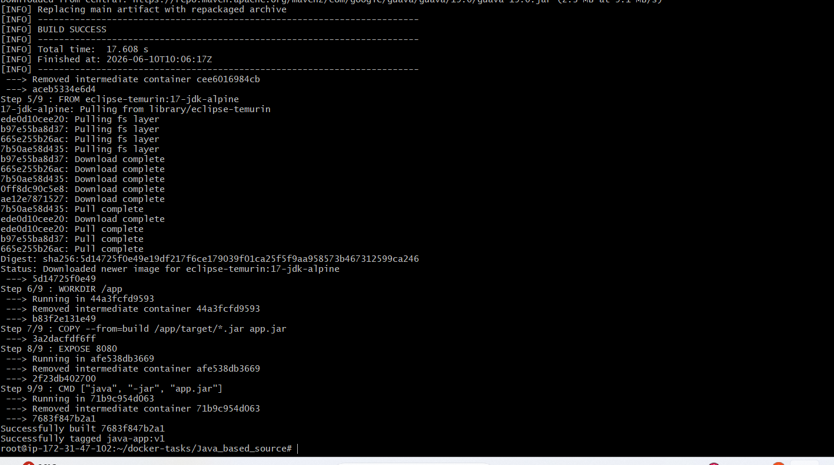docker run -d --name java-container -p 8086:8080 java-app:v1
docker images
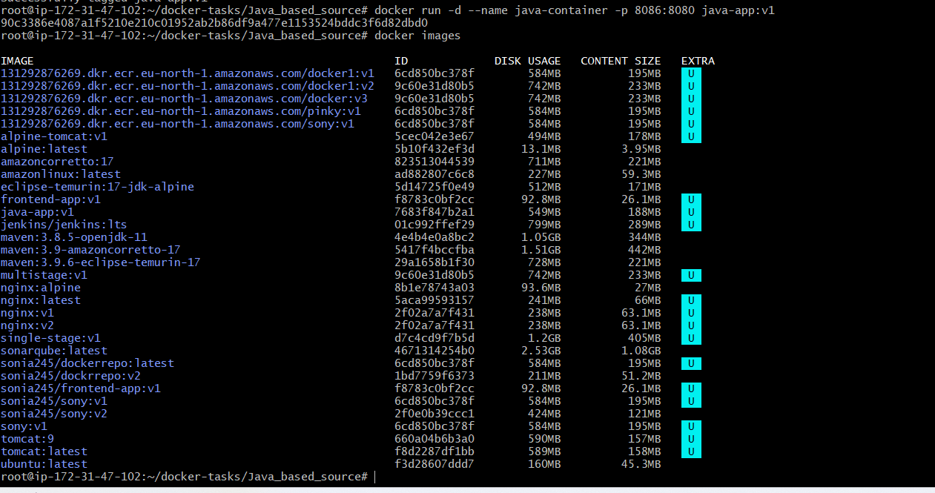
Lets check browser
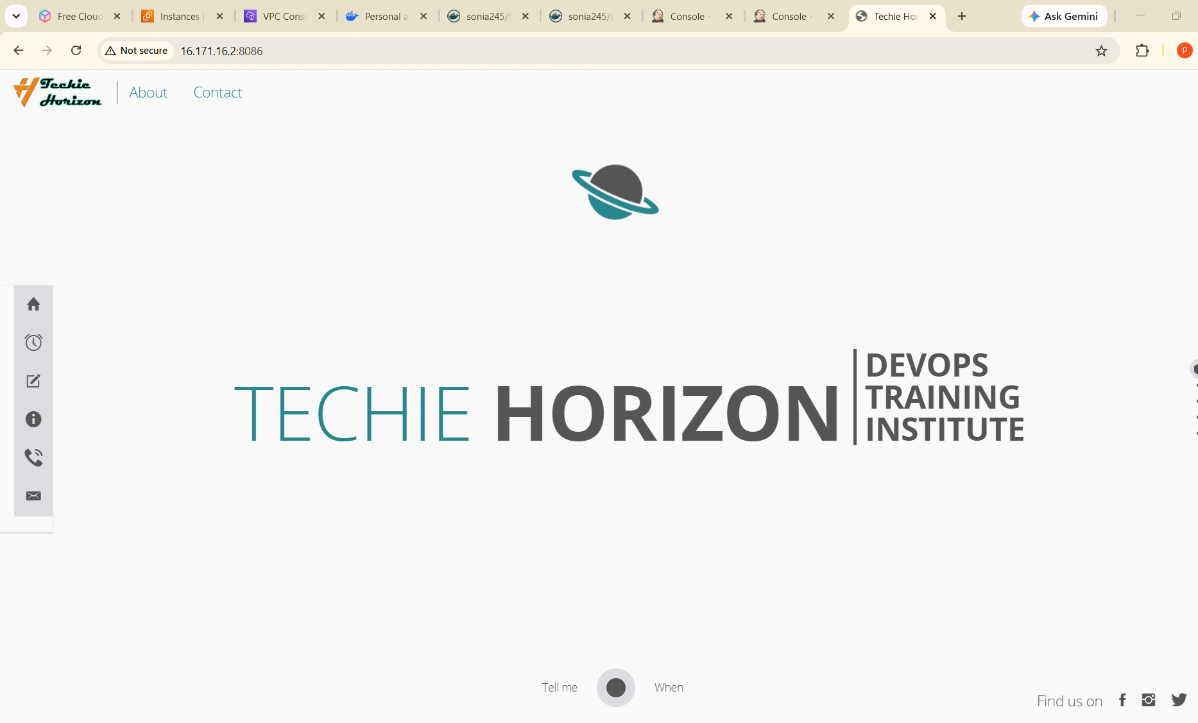
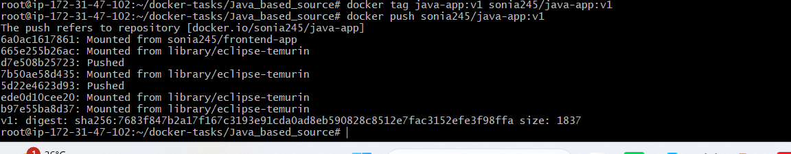
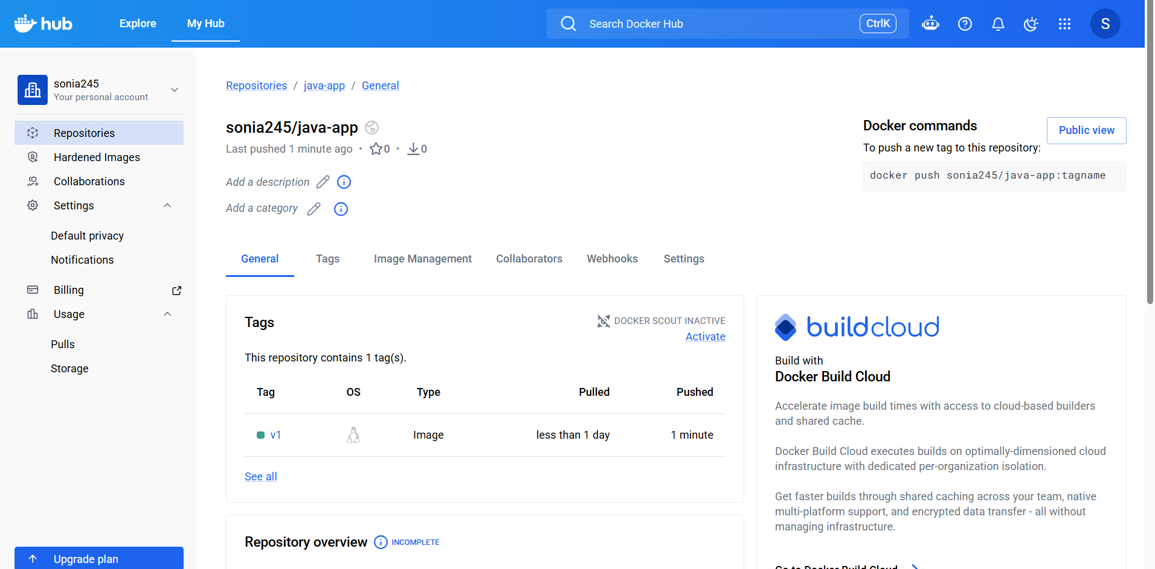

- From theNode.js-based source code, write a Dockerfile, build with tagv1, run, and push it to the Docker registry.
Now let’s do the Node.js-based source code properly.
First go into the node.js project:
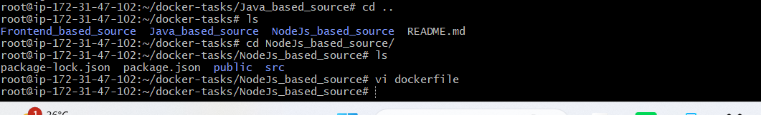
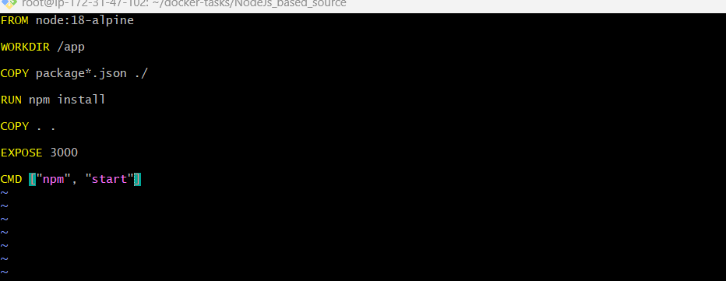

This Dockerfile uses a Node.js image to run the application. First, it creates a working directory called /app inside the container. Then it copies the package.json files and installs all required dependencies using npm install. After installing dependencies, it copies the remaining application files into the container. It exposes port 3000 so the application can be accessed from outside the container. Finally, it starts the Node.js application using the npm start command.

docker build -t node-app:v2 .
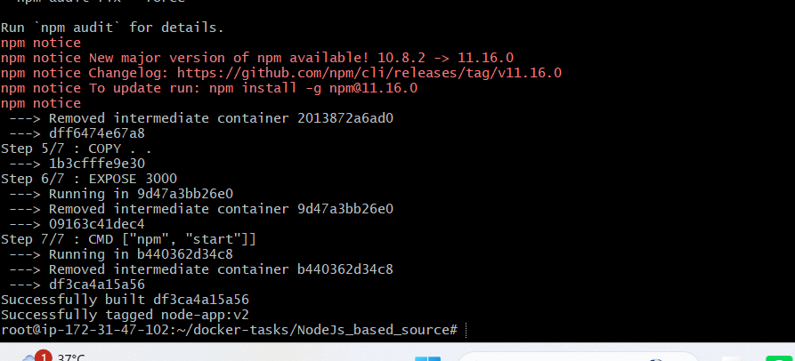
Lets check docker images
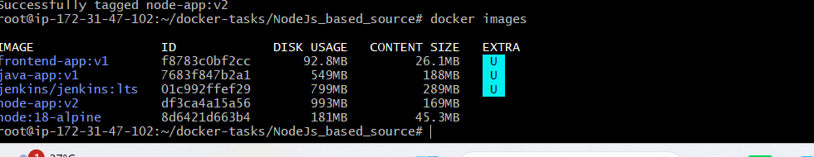
Run the container

docker run -d --name node-container -p 3001:3000 node-app:v1
Docker ps


- Write adocker-compose fileto set up WordPress with a MySQL database.
Create a docker-compose.yml file using command vi
version: '3'

services:
db:
image: mysql:5.7
volumes:
- db_data:/var/lib/mysql
restart: always
environment:
MYSQL_ROOT_PASSWORD: somewordpress
MYSQL_DATABASE: wordpress
MYSQL_USER: wordpress
MYSQL_PASSWORD: wordpress

wordpress:
depends_on:
- db
image: wordpress:latest
ports:
- "8000:80"
restart: always
environment:
WORDPRESS_DB_HOST: db:3306
WORDPRESS_DB_USER: wordpress
WORDPRESS_DB_PASSWORD: wordpress
WORDPRESS_DB_NAME: wordpress

volumes:
db_data:
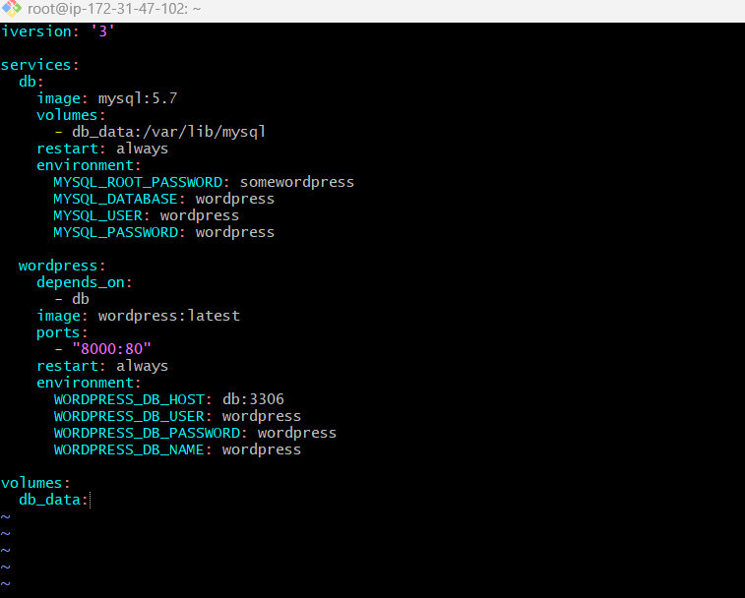
Lets start these services, save the file and run using command
docker-compose up
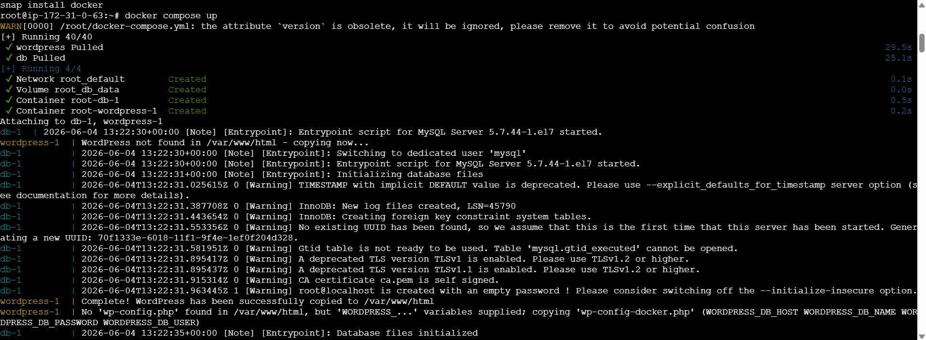
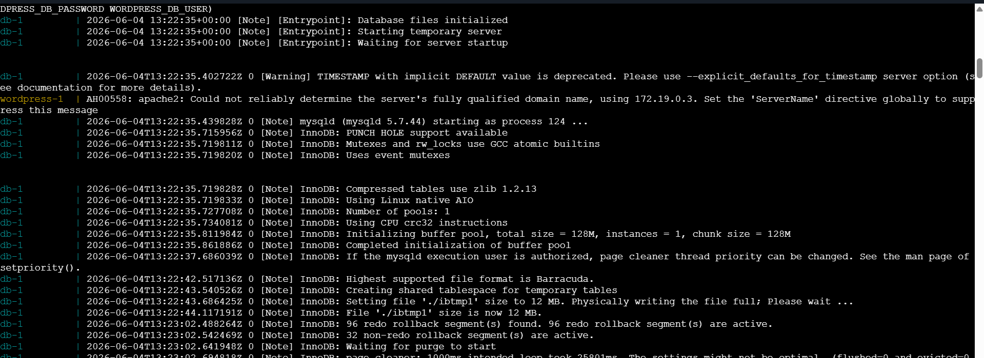
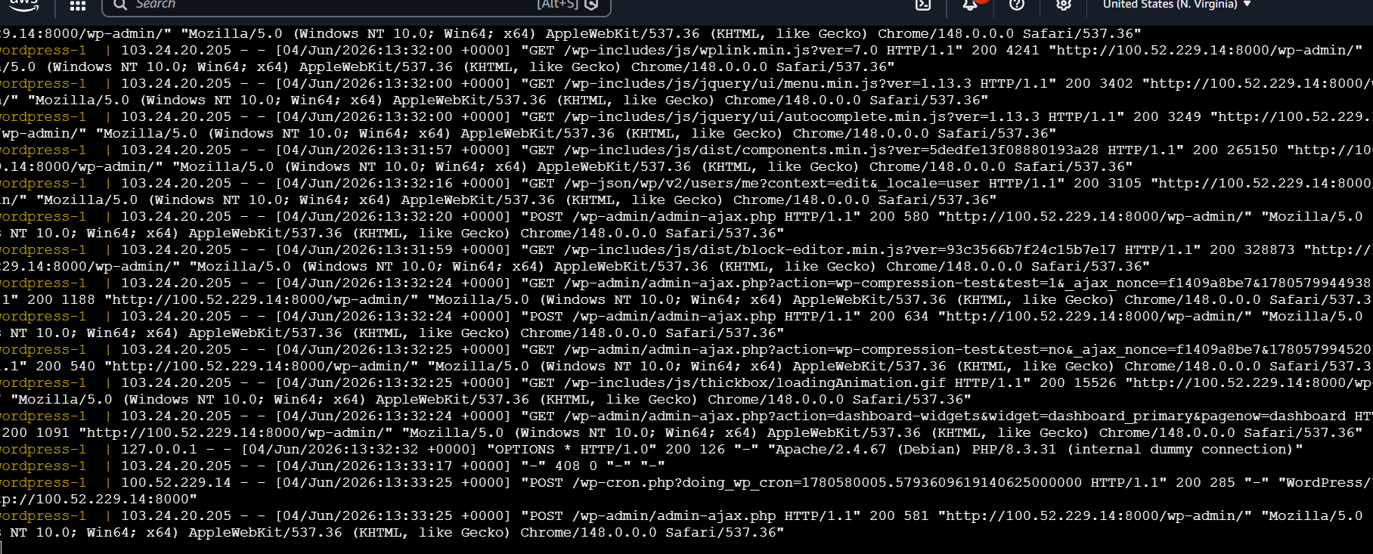
Now if we check in another CLI and do
docker ps
We can see wordpress and mysql are running
By doing docker-compose ps we can see list of containers running in docker-compose
